
Texas A&M University-Commerce
Marketplace/Touchnet Report

How to run a Marketplace Report:

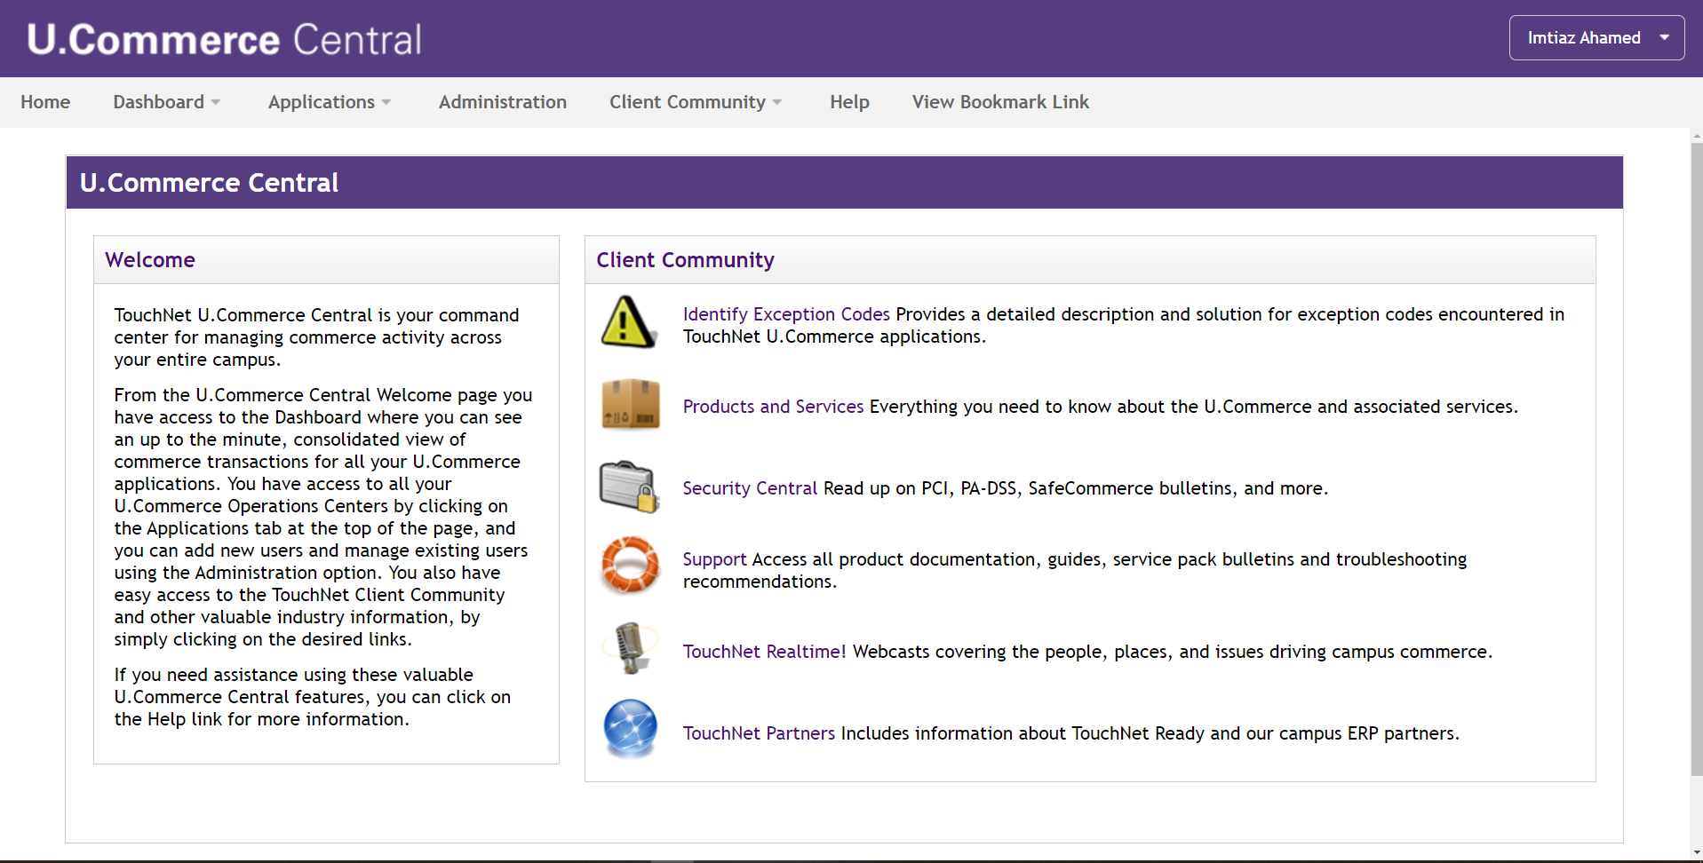
- Step 01: Login To Touchnet/Marketplace (u.Commerce Central)

- Step 02: Click Application > Marketplace > Marketplace Report > Store> Study Abroad Payment (your desired store) > By Products >

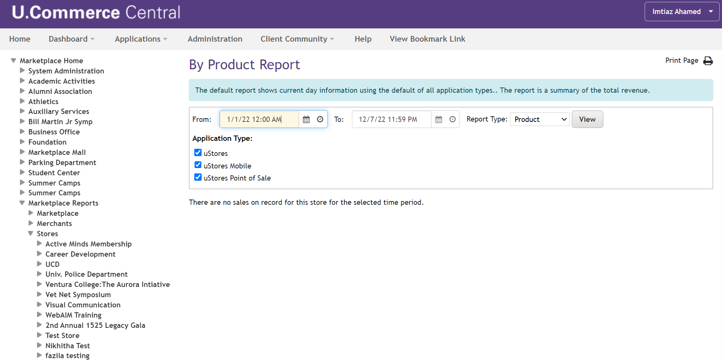

- Step 03: Select a Time Range > click View > Check Box Italy (your desired product out of store) > View Multiple Product Detail Report >
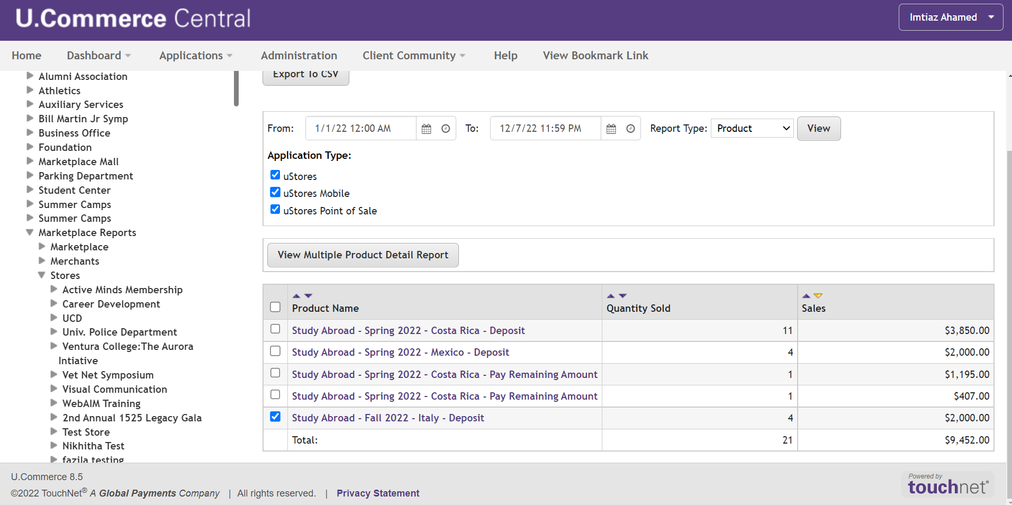

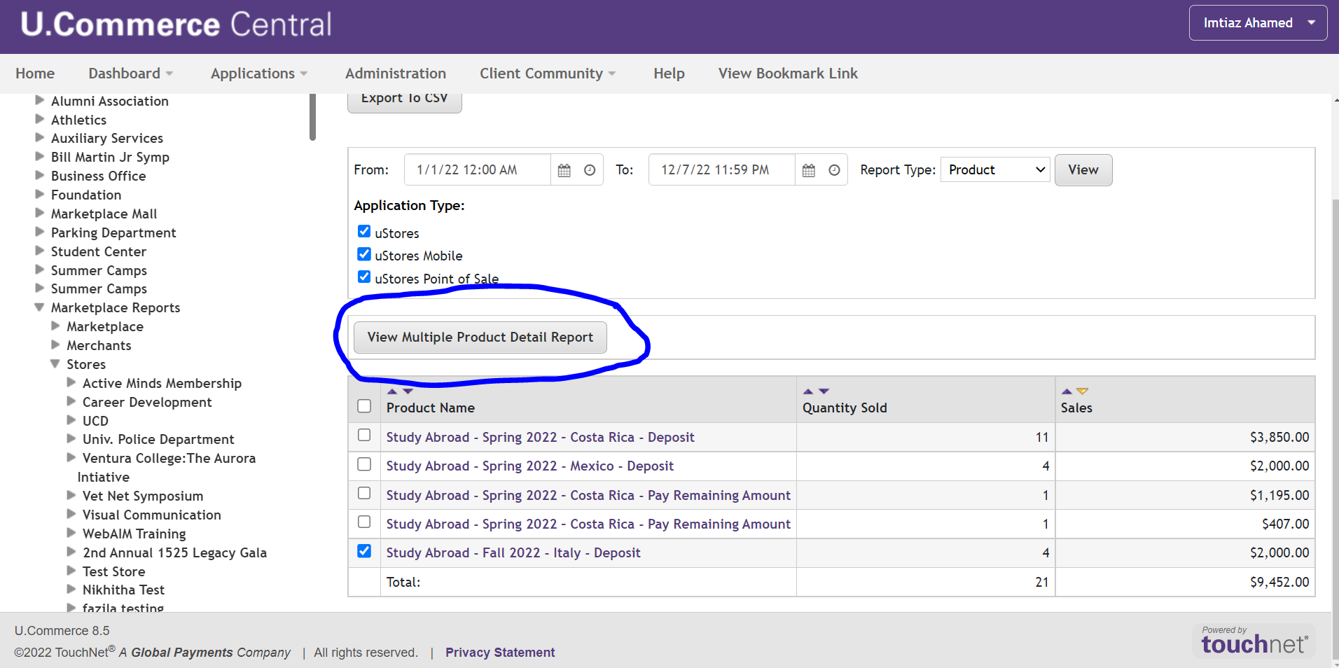

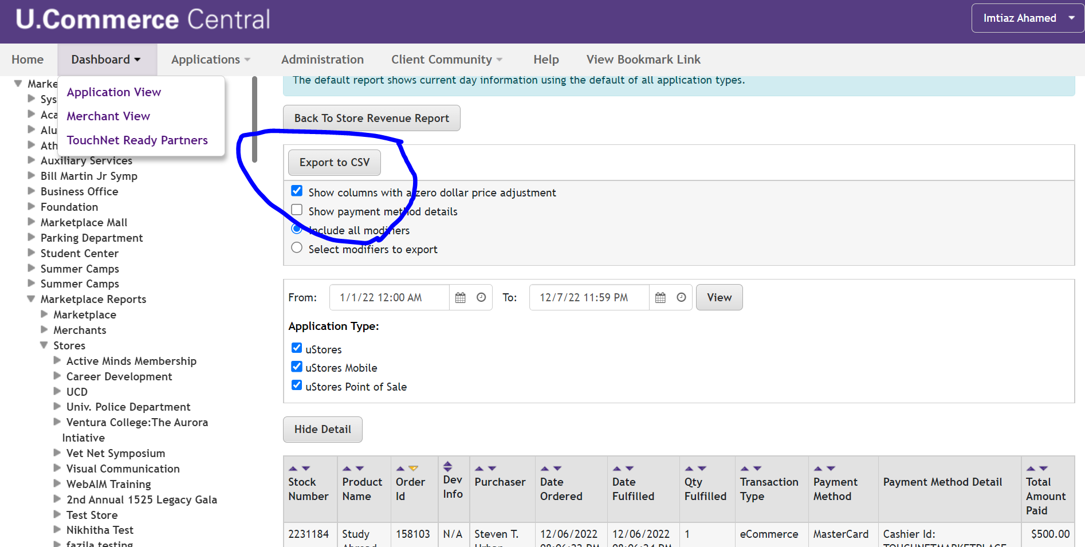
- Step 04: Export to CSV

NOTE: Marketplace Reports can be generated in several formats, By Products, By Revenue, By Payment Type, By Merchant and other, It depends on Users what criteria best fits their report.

MARKETPLACE ADMINISTRATORS
For any issue regarding Marketplace, Touch base with:
Jon Puttonen, BSMS
Senior Business Analyst | Oracle Database Administrator | Banner Administrator
Financial Services | Business Administration, 190
P: 903.468.3137

Imtiaz Ahamed, BBA, MBA, MSBA
Business Analyst
Financial Services | Business Administration, 170 | F
P: 903.886.5053

